The Closet Creature

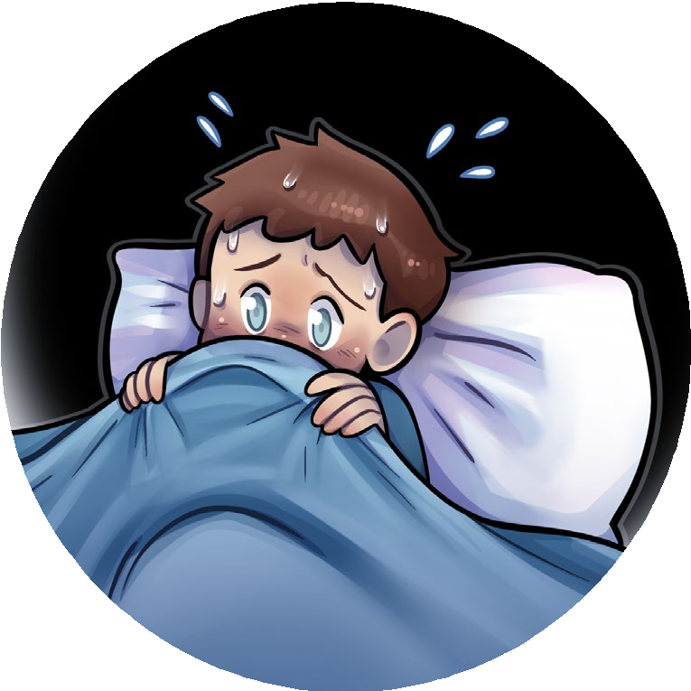

Bump! Bump! Scratch! Adam opened his eyes and pulled the covers up to his chin. He stared around his room, searching the darkness for the thing that was making those scary sounds.

The closet door moved as something banged on it from the inside. “Who’s there?” Adam asked in a shaky voice. The closet slowly began to open. Adam jumped out of bed and ran to the closet door, slamming it shut with his palms. He grabbed his desk chair and propped it against the door handle. Then he ran out of his room and down the hall. His brother’s door was wide open, and Adam jumped onto David’s bed.

“Adam?” David asked in a groggy voice. “What are you doing in here?” Adam tugged on David’s arm. “There’s something in my closet!” “You probably had a bad dream. Go back to bed.” Adam yanked the blankets off the bed. “It wasn’t a dream. I was awake, and the closet door started opening by itself!” David sighed. “Fine. But when we don’t find anything, you have to promise to leave me alone for the rest of the night.”

Adam nodded. David reached into his desk drawer and pulled out a flashlight. Then they headed to Adam’s room. Adam stopped in the doorway. He could hear something scratching his closet door. “Do you hear that?” Adam asked.

David nodded. He walked over to Adam’s bed and pulled the case off one of the pillows. He opened the pillowcase.

“You open the door very slowly, and I’ll grab whatever it is.”

Adam slid the chair to the side and pulled the closet door open a crack. Something banged against the door, trying to force it open. Adam took a deep breath and opened the door a few more inches. A small furry creature ran right into the pillowcase.

“I got it!” David said, closing the pillowcase and holding it in the air. “What is it?” Adam moved closer as David peeked inside.

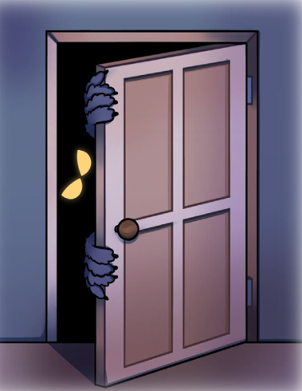

David put the pillowcase on the bed and an orange cat climbed out. Adam scooped the cat up. “Apricot? How did you get trapped in my closet?” David laughed. “The poor cat. If I was locked in your closet with your stinky shoes, I’d be banging on the door to get out, too!”

“Poor, Apricot,” Adam said. “You were probably more scared than I was.”